IMPLEMENT CLIENT SCRIPT &
UI POLICY (INCIDENT)
SERVICE NOW PROJECT DOCUMENTATION

ROLE | NAME
Team Lead | M. Nathiya
Member | S. Harshini
Member | S. Megaladevi
Member | K. Divya
Member | V. Rama Shanmugi

1. Project Overview
This project demonstrates the implementation of a Client Script and a UI Policy on the ServiceNow Incident table. The configuration provides dynamic form behavior and helps ensure that important incident information is captured correctly.

2. Objectives
- Configure a Client Script on the Incident table.
- Create the High Impact Control UI Policy.
- Apply the policy when Impact is set to 1 - High.
- Make Assignment group mandatory for high-impact incidents.
- Demonstrate the expected dynamic behavior on the Incident form.

3. Client Script
A Client Script runs on the client side of a ServiceNow form. It is used to perform dynamic actions, validate data, or change form behavior based on user interaction.
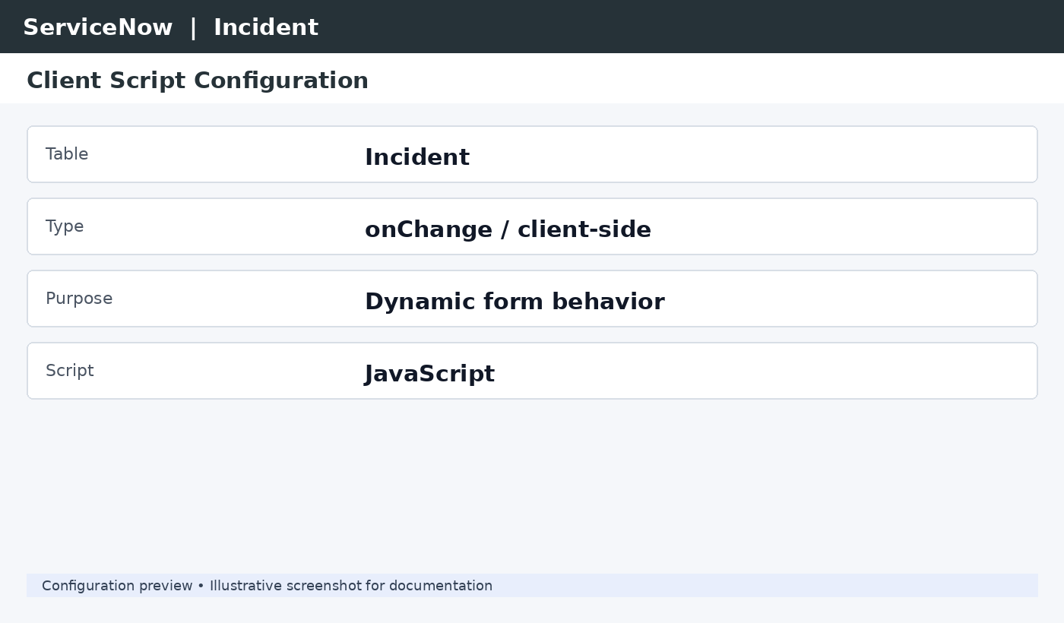
Figure 1: Client Script configuration – illustrative screenshot

4. UI Policy Configuration
A UI Policy controls field behavior on a form without requiring complex scripting. The policy below is configured for high-impact Incident records.
Property | Value
UI Policy Name | High Impact Control
Table | Incident
Active | True
Condition | Impact is 1 - High
On Load | True
Reverse if False | True
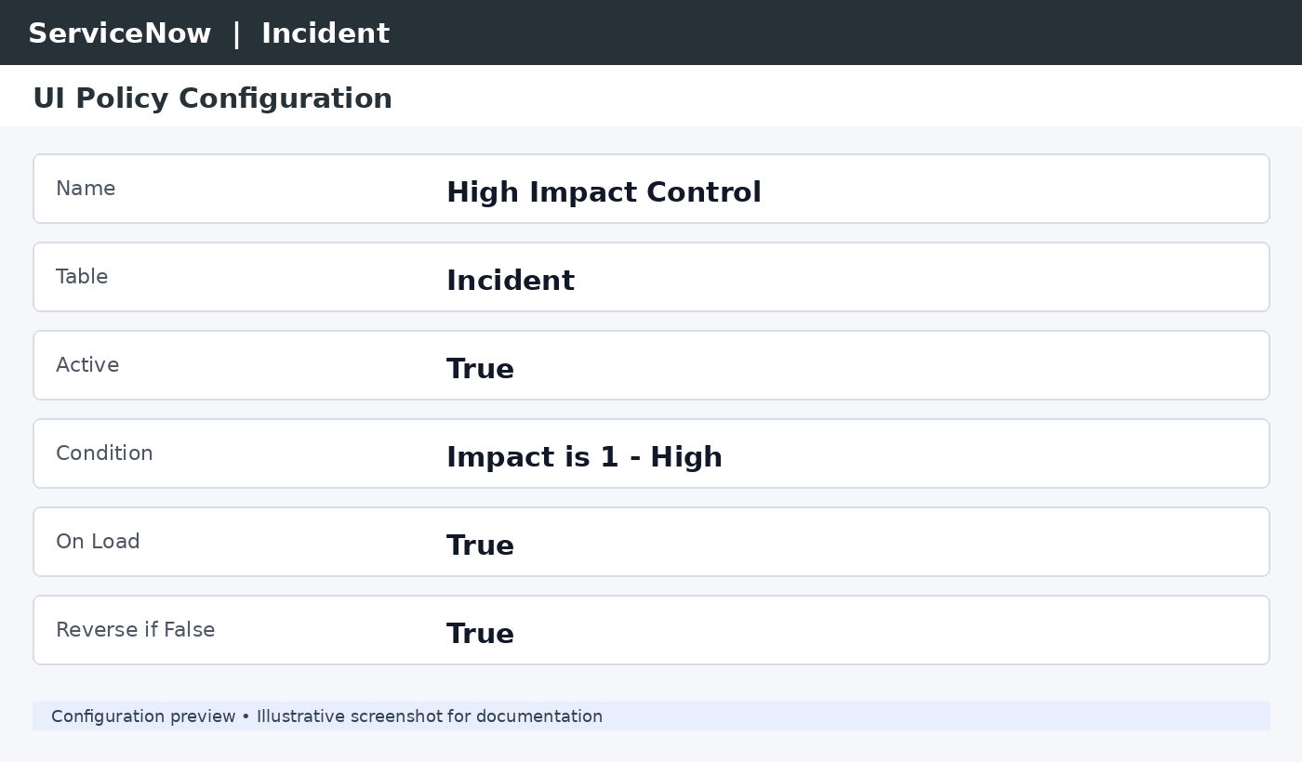
Figure 2: High Impact Control UI Policy – illustrative screenshot

5. Policy Condition
When the Incident Impact field is set to 1 - High, the UI Policy becomes active. Because Reverse if False is enabled, the configured behavior is reversed when the condition is no longer true.

6. UI Policy Action
A UI Policy Action defines the field-level behavior that is applied when the UI Policy condition is satisfied.
Field / Property | Configuration
Field | Assignment group
Mandatory | True
Visible | True
Read-only | False
Triggered when | Impact = 1 - High
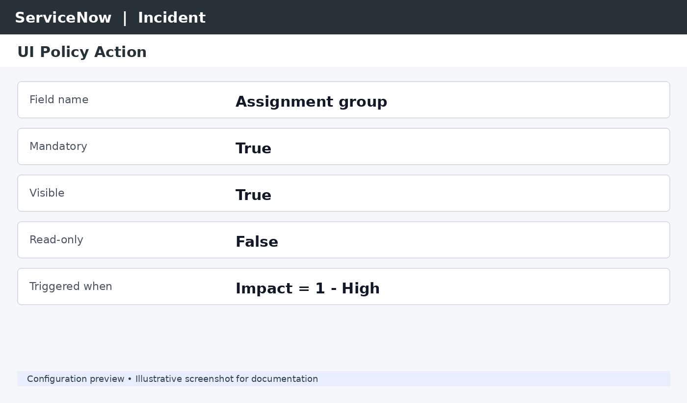
Figure 3: Assignment group UI Policy Action – illustrative screenshot

7. Working Flow
- Open an Incident record.
- Set Impact to 1 - High.
- The High Impact Control UI Policy is triggered.
- Assignment group becomes mandatory.
- If Impact changes to another value, the policy is reversed.

8. Expected Result
When Impact is set to 1 - High, the Incident form applies the configured UI Policy. The Assignment group field becomes mandatory, helping ensure that high-impact incidents contain the required assignment information.
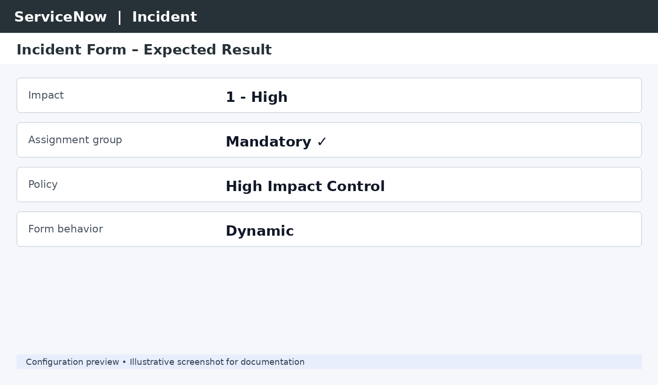
Figure 4: Expected Incident form result – illustrative screenshot

9. Conclusion
The implementation demonstrates how Client Scripts and UI Policies can be used in ServiceNow to create dynamic and user-friendly Incident forms. The configuration improves field control, validation, and consistency based on Incident Impact.

10. Technologies Used
- ServiceNow
- Incident Table
- Client Script
- UI Policy
- UI Policy Action
- JavaScript
END OF DOCUMENT

